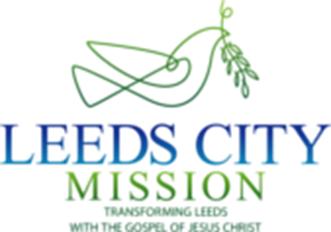

**GARDEN PARTY PRAISE**

***Summer Praise Open Day***

***Supporters Luncheon***

***Afternoon Garden Party & Bargain Book Sale***

**Saturday 29 June**

**Leeds City Mission Hub, Mistress Lane, Armley, Leeds LS12 2LJ**

*Guest Speaker:* ***Carl Knightly (London)***

*Chairman of City Mission Movement UK*

**12.30—1.30 pm** Arrive and enjoy a free light lunch—sandwiches,quiche, sausage rolls, buns & cakes

**1.30 pm—2.30 pm** Report back, Mission Update & also inspiring Message —

(Carl Knightly)

**2.30 pm—4.00 pm** IceCream. teas & other refreshments served on the lawn

Bargain christian book sale inside City Mission Hub

**4.00 pm** Proceedings conclude

***All Welcome!***

***Travel: By Bus -*** **15, 16A, 81, 86, 87** (Armley Town Street — 30 seconds walk)

**14, 72, X6, X11** (Junction Armley Road/Stanningley Road — 2 mins walk)

***By Car - Plenty of free on-street parking***

***Two minutes drive from Armley Gyratory***

***You are welcome to attend either all or just part of the afternoon programme***

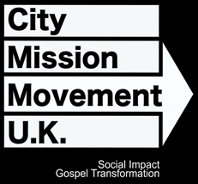

**LEEDS CITY MISSION IS A MEMBER OF**

**THE CITY MISSION movement UK  
 & a UK Registered Charity 234431**