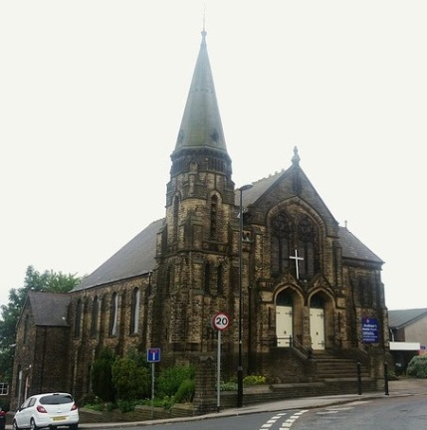

St. Andrew’s Methodist Church
Robin Lane, Pudsey
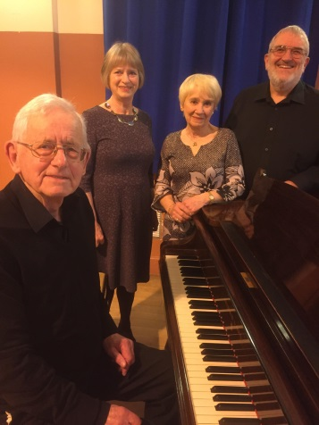
Autumn Concert
Sunday 8th October 2017
at 6:30 pm
with
Yorkshire Clarinet Ensemble
Aires and Gracenotes
David Grainger, Classical Guitarist
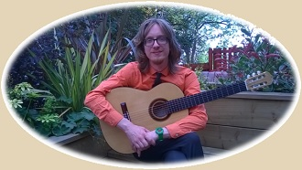
Free admission, retiring collection, refreshments at the close
All Welcome!

