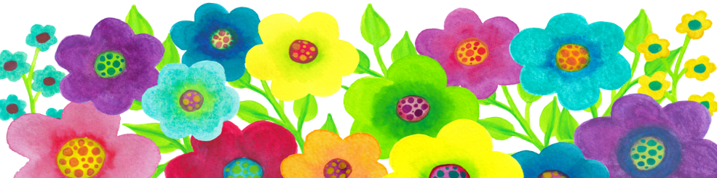

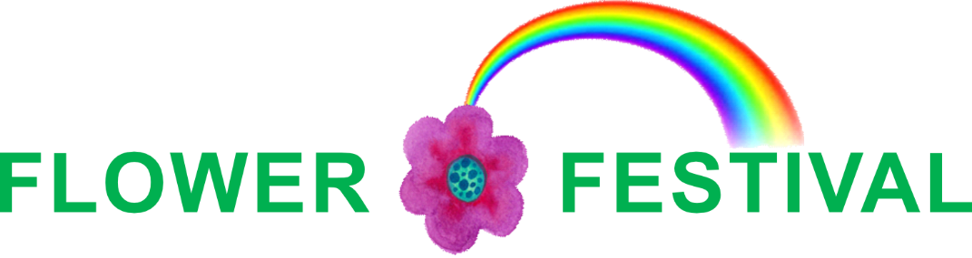

27th – 30th June 2019
“I AM”

The theme for this year’s Flower Festival at Otley Parish Church is “I AM”
and we hope that the opportunity to pause and reflect on the unchanging,
ever-present nature of God,
as reflected by a series of beautiful floral and craft displays,
will provide comfort and hope in these turbulent times.

The Festival starts with a preview evening on Thursday 27th when guests can enjoy the arrangements with wine and canapés, along with music by local artists.
It continues on Friday and Saturday, from 10am to 4pm, and Sunday, from 12 noon to 4pm,
with tea, coffee and light refreshments available to buy in the café.

There will also be a well-stocked plant stall, beautiful hand-made cards
and a themed bookstall provided by Cornerstone of Skipton.

Entrance to the main Festival is FREE with donations welcome on the day.
Tickets for the preview evening will be available to buy from Otley Parish Church office
on 01943 465927
or by email
info@otleyparishchurch.org

